|  |
| --- |
| C:\Users\CHAYAPATHI-CPN\Desktop\download.png  **Department of Information Science and Engineering** |
| **Acharya Institute of Technology** |
| Acharya Dr. Sarvepalli Radhakrishnan Road,Bangalore-560107 |

|  |  |  |  |  |  |
| --- | --- | --- | --- | --- | --- |
| **WEEKLY PROGRESS REPORT** | | | | | |
| **Batch No** | | **05** | | | |
| **Guide** | |  | | | |
| **Project Title** | | **IoT based Wireless Smart Board** | | | |
| **Progress Report No** | | **5** | | | |
| **Date of Submission** | | **29 April 2019** | | | |
| **Date** | | **From: 2 April 2019** | | | **To:22 April 2019** |
|  | | | | | |
| **Sl. No.** | **Student Name** | | **USN** | **Signature with date** | |
| **1** | Pravesh Kasaundhan | | **1AY15IS072** |  | |
| **2** |  | |  |  | |
| **3** |  | |  |  | |
| **4** |  | |  |  | |
|  | | | | | |
|  | | | | | |

Progress Report:

List of Features Implemented as per the Gantt chart

1. Configure and test Raspberry pi using python script to get the IP address of the PI
2. Implementation of code and testing the script to get the Current Date and Time
3. Integrate the python script written for acquiring the IP address and current date and time to conduct Integration testing for PI is reachable to the Device
4. Integrate the code for LCD and PI to conduct Integration Testing for Correct Functioning
5. **Configure Pi & Get IP address.**

Please follow the below steps to have a working SSH connection:

* Install and burn the latest Raspbian Wheezy OS onto the SD card for the Raspberry Pi
* While the Raspberry Pi is switched off, connect one side of the Ethernet cable to Raspberry Pi and other side to the RJ45 jack of the PC/Laptop
* Open LAN properties and make sure that IPV4 properties are set to Obtain IP address automatically as shown below:

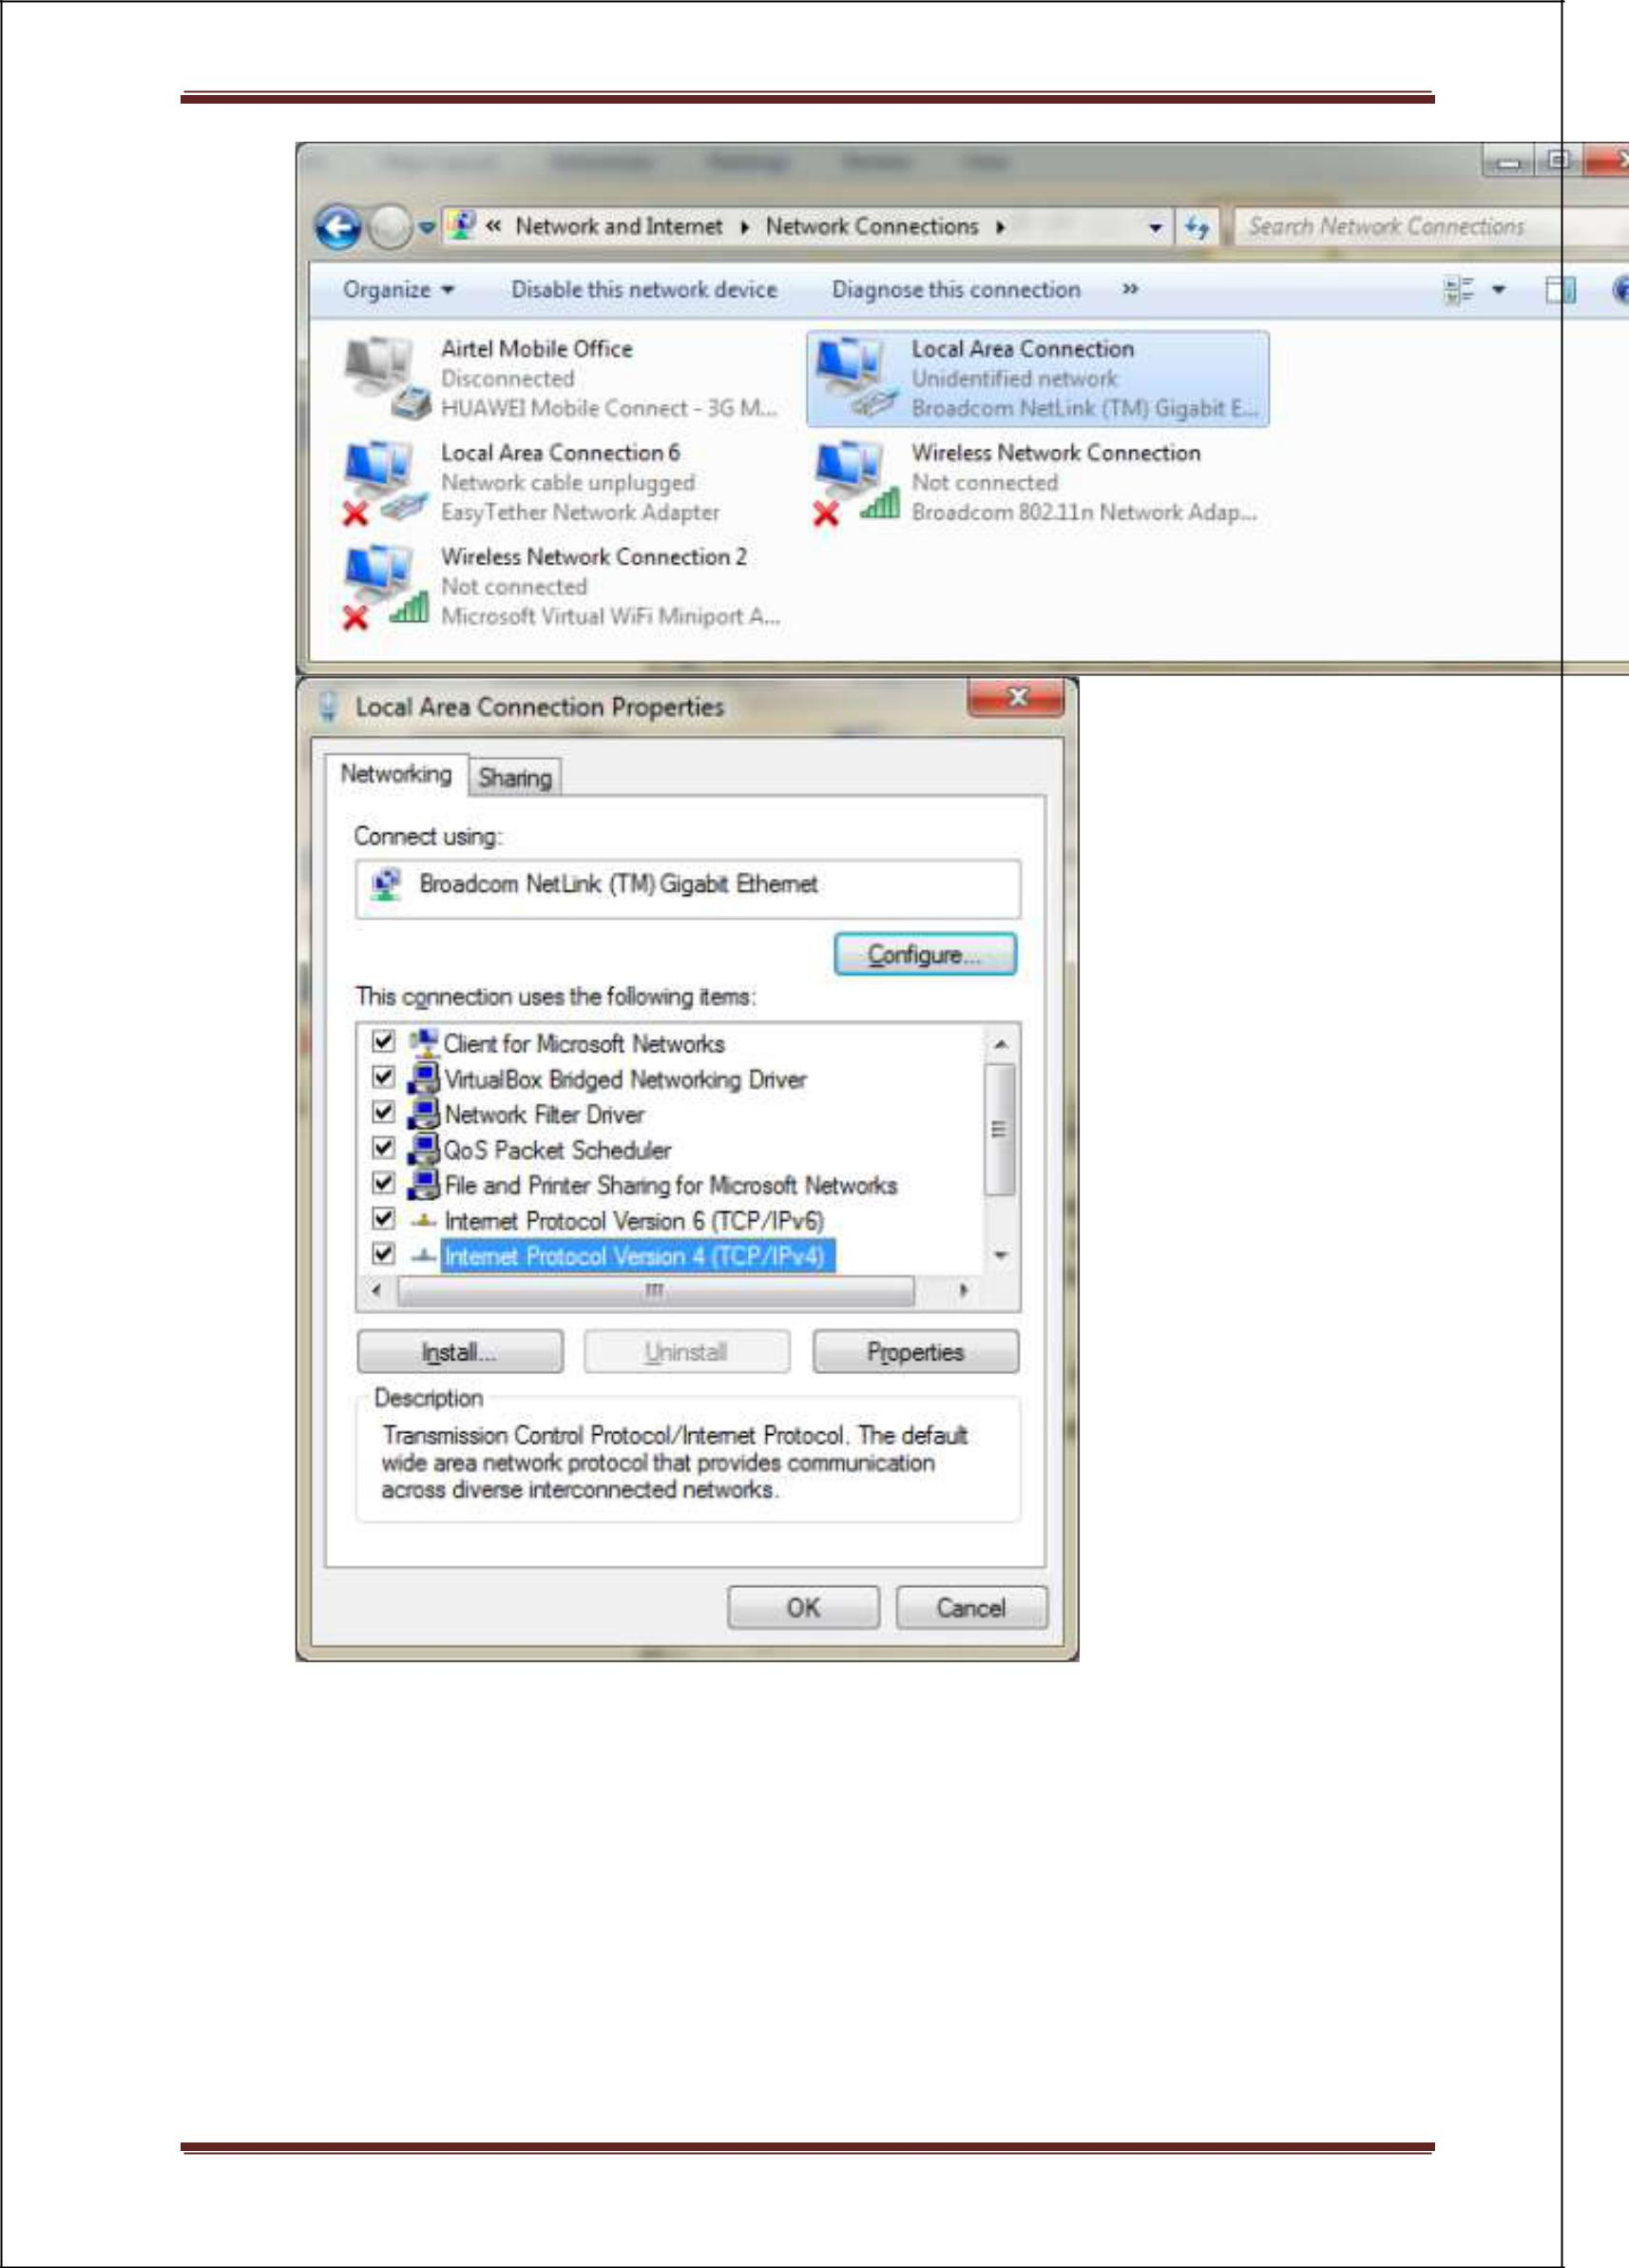



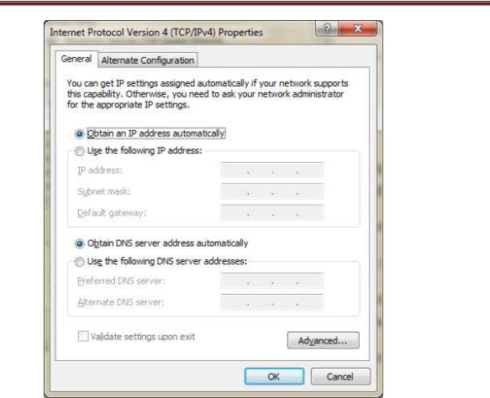

* We now need to determine the IP of our PC/Laptop when it’s connected to the Raspberry Pi
* Now power on the Raspberry Pi while making sure that the network cable is connected on both ends
* Wait for a min or two. You’ll notice that the PC/Laptop will scan and then show a small warning indicating the presence of an unidentified network.

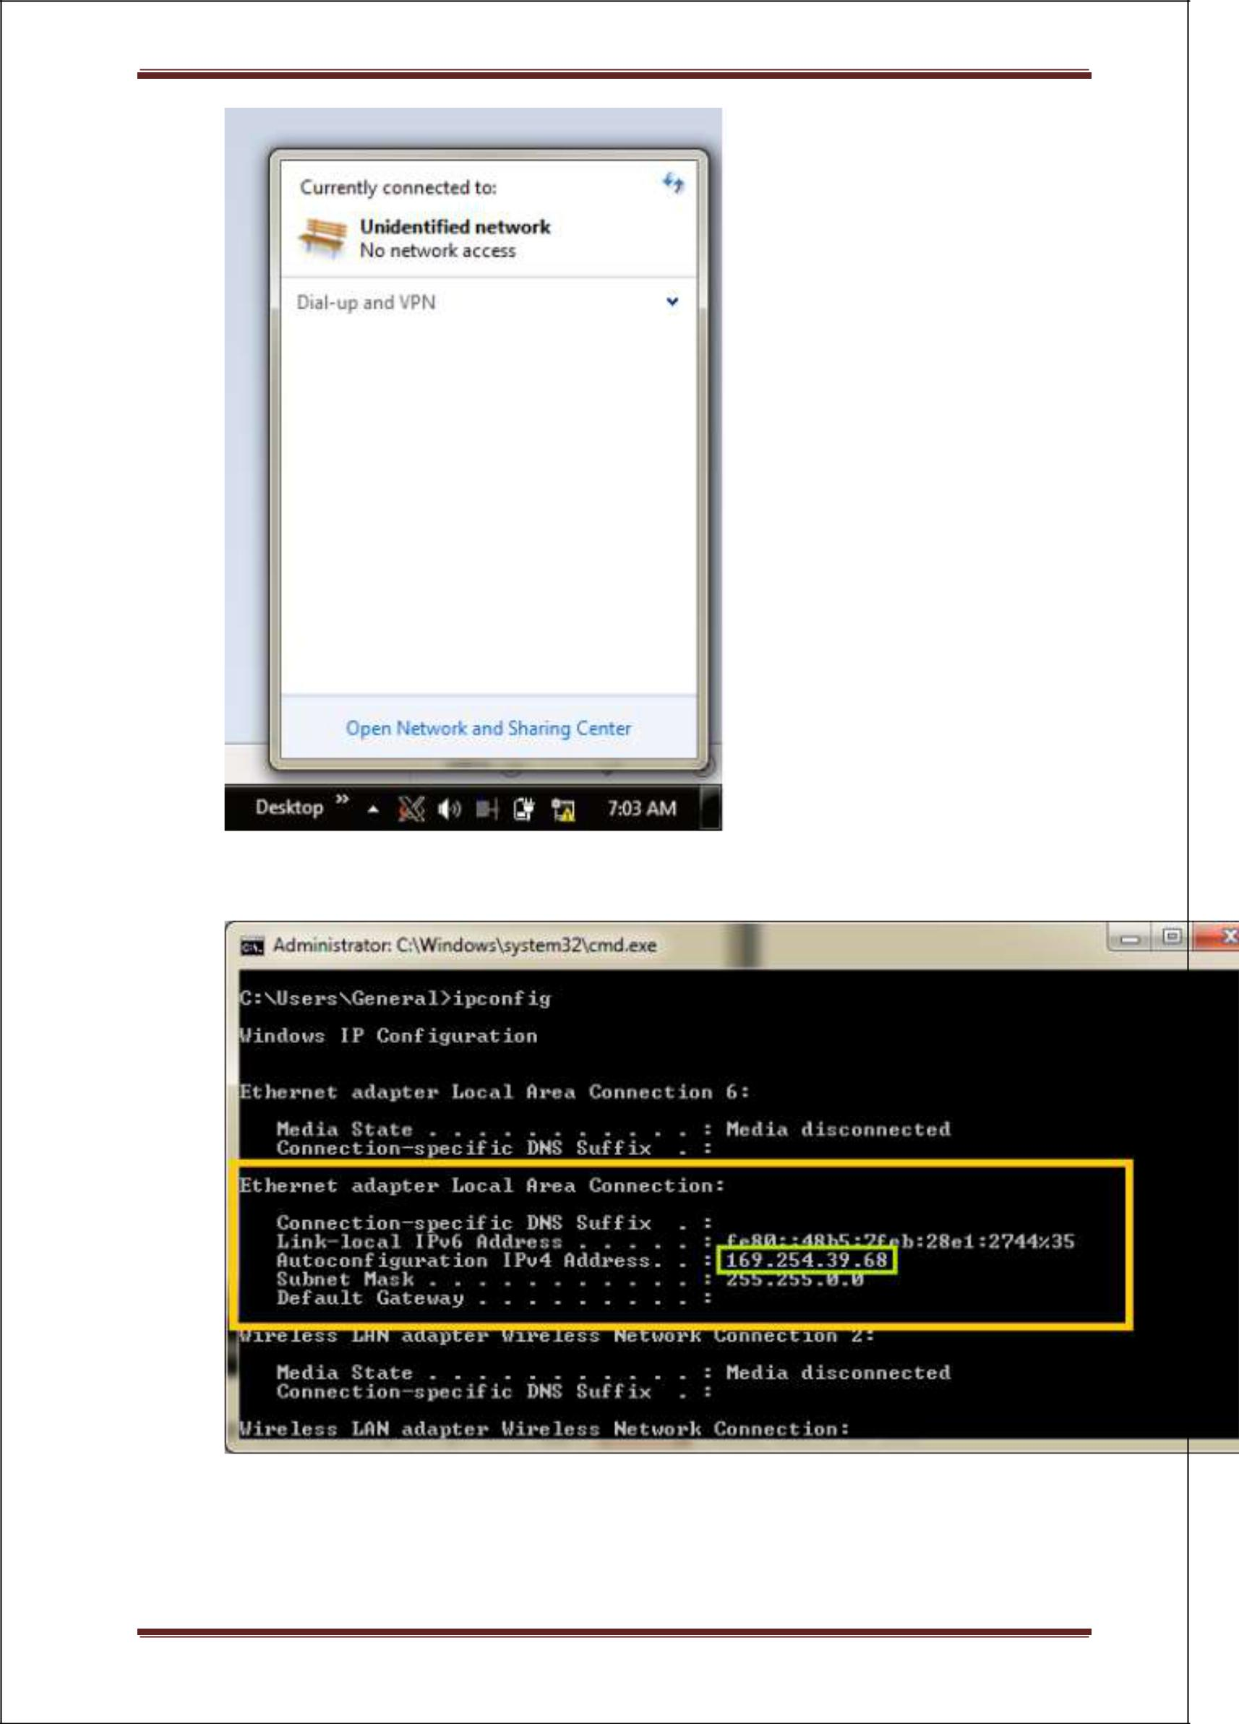

* Now, open command prompt and type **ipconfig**. Note the IP of the Ethernet Adapter Local Area Connection as shown below:



In our example, its **169.254.39.68**

* Now, power off the Raspberry Pi and take out the SD Card. Plug in the SD card into a card reader and open it. You should see a couple of files

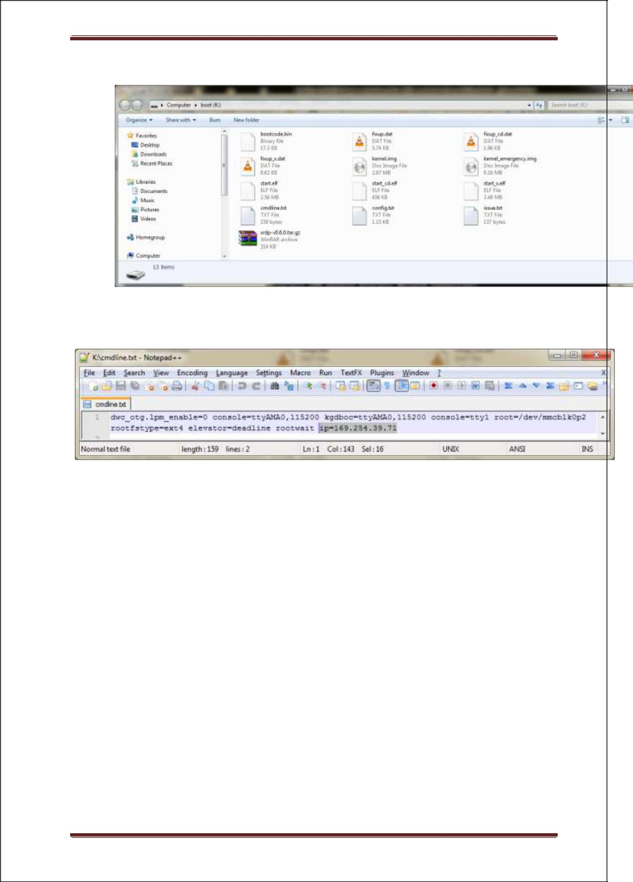

* Open the **cmdline.txt** file and append this to the end of it: **Ip=169.254.39.71**



Please change the IP accordingly and assign a unique value (while making sure you don’t go beyond the subnet mask). Preferably, change only the last parameter.

For example, if your LAN’s ip is **169.254.0.1**, we recommend using **169.254.0.3** as the IP for Raspberry Pi in **cmdline.txt**

* Save the **cmdline.txt** file without making any other changes
* Plug this back into the Raspberry Pi and with the Ethernet cables connected, power on the Raspberry Pi
* Wait a couple of minutes while the Raspberry Pi tries to establish a local network connection with our PC/Laptop
* Once you see the network warning message as shown above, ping the Raspberry
* Pi to see if it’s live on the network as follows
* Open CMD prompt
* Type **ping ipaddress of raspberry-pi**

Ex: **ping 169.254.39.71**

If all went good, we will see the Pi responding back to the ping requests as shown below:

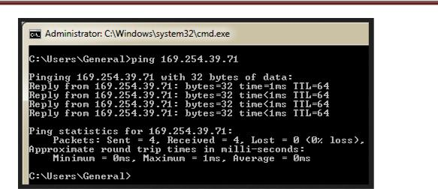

* Now it’s time to SSH into the R Pi. Open putty client and type in the IP address of the Raspberry Pi (169.254.39.71) and hit Open

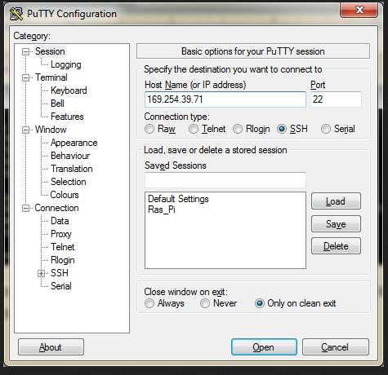

We get a certificate trust warning message (if SSHing for the first time) which we shall accept.

Once done, we’ll see the login terminal:

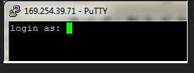

Enter pi as the user name and password is raspberry

After entering the credential hit enter to SSH in to raspberry Pi

If we are successful then we would see the screen below on our computer screen

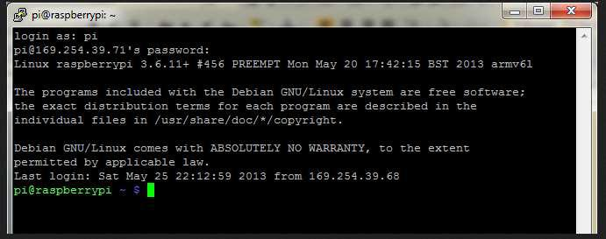

1. **Configure the LCD display System**

To start displaying anything on the screen we need to go through a few steps to setup and disable a few settings. Firstly we should disable the screensaver and any energy saving settings as we don’t want our screen to go to sleep at all when it’s in use, wouldn’t be very useful if it went blank every 5 minutes.

While connected to your pi over SSH type

Sudo nano /etc/xdg/lxsession/LXDE/autostart

Autostart file is a file that runs when your pi boots.

To disable the screensaver add a # to the beginning of the line, this comments the line out.

@xscreensaver -no-splash

Next add these lines underneath the screensaver line

@xset s off

@xset -dpms

@xset s noblank

This disables power management settings and stops the screen blanking after a period of inactivity.

Now that is done we should prevent any error messages displaying on the screen in the instance that someone accidentally power cycles the pi without going through the shutdown procedure. To do this we add the following line underneath the lines you just added.

@chromium --noerrdialogs --kiosk [http://localhost/fileread.php](http://localhost/FileRead.php) --incognito

The url [http:localhost//fileread.php](http://fileread.php/) is a file which is to be opened in kiosk mode to display

Hit ctrl-O and then ctrl-X again to write out and exit the file and now type.

Reboot the system to apply changes made to system

Sudo reboot

1. **Code Implementation**
   1. **Client Side Code**

The client side code is stored on raspberry pi apache we server in the following directory

/var/www/

The file name is echo3.html

Following are the contents of the file

<!DOCTYPE HTML>

<html>

<head>

<title>Write to a text file</title>

</head>

<body>

<meta name="viewport" content="width=device-width, initial-scale=1, maximum-scale=1">

<h1>ELECTRONIC NOTICE BOARD</h1>

<form action="myfile.php" method='post'>

<textarea rows="10" cols="50" name='textblock'></textarea>

<input type='submit' value='Display'>

</form>

</body>

</html>

This page opens with a heading ELECTRONIC NOTICE BOARD and opens up a text box in which user can enter whatever text which he/she wants to display on the screen and as soon as he hits display button an internal php page name as myfile.php opens a file and stores the user entered text in file on Raspberry Pi.

<?Php

// Open the text file

$f = fopen("web.txt", "w");

// Write text in to the file

Fwrite($f, $_POST["textblock"]);

Fwrite($f,"\r\n");

Close the text file fclose($f);

Open file for reading, and read the line $f = fopen("web.txt", "r");

Read text

//echo fgets($f);

Fclose($f)

?>

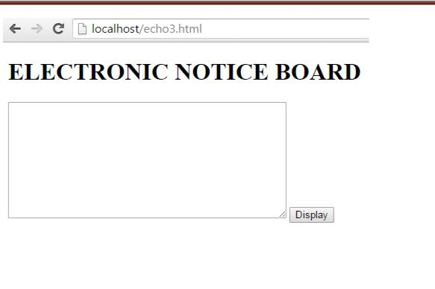

* 1. **Server Side Code**

When Raspberry Pi opens it open a web page in chromium in kiosk mode which displays the user sent messages from android phone to LCD screen.

<?Php

Echo "<h1 align='center'> <font color=red font face='arial' size='10pt'</font> Acharya Institute of Technology </h1>";

Echo "<h2 align='center'> <font color=green font face='arial' size='5pt'</font>Raspberry Pi based Wireless notice board</h2>";

$myfile = fopen("web.txt", "r") or die("Unable to open file!");

$data = fread($myfile,filesize("web.txt"));

Fclose($myfile)

Echo "<p align='center'> <font color=blue size='5pt'>$data </font> </p>";

Header("refresh:10");

?>

This Web Page Displays the title as the name of our college and sub heading as Electronic Notice Board. The Page is programmed to automatically refresh every 5 second to update the most recent message. The Page looks like this



**Testing**

|  |  |  |  |  |  |  |  |  |  |  |  |  |  |
| --- | --- | --- | --- | --- | --- | --- | --- | --- | --- | --- | --- | --- | --- |
| **Test ID** | | **Test Technique** | | **Test Description** | | **Input** | | **Expected Output** | | **Actual Output** | | | **Result** |
| #T1 | | General | | Checking power supply to the Raspberry Pi | | Power Supply | | Red light Indicator glows | | Red light Indicator glows | | | Pass |
| #T2 | | General | | Checking validity of the name and password of WIFI | | valid Name and Password | | Wifi IP configuration | | Wifi IP configuration | | | Pass |
| #T3 | | General | | Checking the connectivity of Wamp Server | | Code Execution | | Green color wamp symbols will be displayed on the task bar | | Green color wamp symbols was displayed on the task bar | | | Pass |
| #T4 | | General | | Check for sucessfull installation of apache web server | | command | | Default page should open | | Default page should open | | | Pass |
| #T5 | | General | | Check for sucessfull installation of PHP | | Command | | The encoded message should be displayed | | The encoded message should be displayed | | | Pass |
| #T6 | | General | | Check whether the laptop is connected to the ip adress of the Raspberry pi | | IP address | | Laptop should identify and connect to an undefined network | | Laptop should identify and connect to an undefined network | | | Pass |
| #T7 | General | | enter the credential hit enter the SSH into raspberry Pi | | Login Name | | prompt with the login name should open | | prompt with the login name should opened | | Pass |  | |
| #T8 | General | | check the client side code | | Code Execution | | A web page with the encoded message should open | | Blank white screen appeared | | Fail | Code error: One bracket was found misssing | |
| #T9 | General | | check the Server side code | | Code Execution | | A web page with the message "Acharya Institute of Technology","Raspberry Pi based Wireless notice board","Welcome"should open | | Blank white screen appeared | | Fail | Code error: One keyword was written wrong | |
| #T10 | General | | Checking validity of name and password of WIFI | | invalid name and password | | enter valid name and password | | enter valid name and password | | Pass |  | |
| #T11 | General | | Checking the connectivity without wamp server | | Code Execution | | red color wamp symbols will be displayed on the task bar | | red color wamp symbols will be displayed on the task bar | | Pass |  | |
| #T12 | General | | enter the invalid credential hit enter the SSH into raspberry Pi | | Login Name | | enter valid login name | | enter valid name and password | | Pass |  | |

Guide Project Coordinator HOD-ISE

(Signature with Date) (Signature with Date) (Signature with Date)